***Project Report on***

***Deploying HPC Cluster***

***On Containers***

**

*Submitted in partial fulfillment for the award of*

***Post Graduate Diploma in High Performance Computing System Administration*** *from* ***C-DAC ACTS (Pune)***

***Guided by: Mr. Ashutosh Das*** *Presented by:*

***Mr. Ravindra Singh (****230340127048****)***

***Mr. Vikas Kumar (****230340127053****)***

### *Ms. Shradha Sonawane(230340127008)*

### *Mr. Madhu Sen (230340127003)*

***Mr. Rajnikant Kundan (****230340127046****)***

# *Centre of Development of Advanced Computing (C-DAC), Pune*



CERTIFICATE

# *TO WHOMSOEVER IT MAY CONCERN*

***This is to certify that***

***Mr. Ravindra Singh***

***Mr. Vikas Kumar***

### *Ms. Shradha Sonawane*

### *Mr. Madhu Sen*

***Mr. Rajnikant Kundan***

***have successfully completed their project on***

***Deploying HPC Cluster***

***On Containers***

***Under the Guidance of Mr. Ashutosh Das***

***Project Guide Project Supervisor***

# *HOD ACTS*

***Mr.***



PG-DHPCSA

ACKNOWLEDGEMENT

This project “ Deploying HPC Cluster on Containers **”** was a great learning experience for us and

we are submitting this work to Advanced Computing Training School (CDAC ACTS).

We all are very glad to mention the name of Mr. Ashutosh Das for his valuable guidance to work on this

project. Overcome various obstacles and intricacies during the course of project work.

We are highly grateful to HPC tech team (ACTS training Centre, C- DAC),

For his valuable guidance and support whenever necessary while doing this course Post

Graduate Diploma in High Performance Computing System Administration (PG- DHPCSA)

Through CDAC ACTS , Pune.

Our most heartfelt thank goes to Ms. Swati salunkhe (Course Coordinator, PG- DHPCSA)

who gave all the required support and kind coordination to provide all the necessities like

required hardware, internet facility and extra Lab hours to complete the project and

throughout the course up to the last day here in C-DAC ACTS, Pune.

### *From:*

***Mr. Ravindra Singh (230340127048)***

***Mr. Vikas (230340127053)***

### *Ms. Shradha Sonawane(230340127008)*

### *Mr. Madhu Sen (230340127003)*

***Mr. Rajnikant Kundan(230340127046)***



TABLE OF CONTENTS

1. Introduction
2. Workflow
3. System Requirements
   1. Software
   2. Hardware
4. Setting up the Master
5. Installation of Warewulf
   1. Setting up the Node
   2. Provisioning of the Node
6. Installation of SLURM
7. Installation of Ganglia
8. Troubleshooting
9. References and Bibliography
10. Project Link

Introduction

This project is about deployment of HPC on Containers using Warewulf.

For monitoring we have Ganglia. SLURM has been used to manage

Resources and accounting. This HPC stacks uses Rocky 8.8 Linux as an

Alternative to Centos 7.9.

Workflow

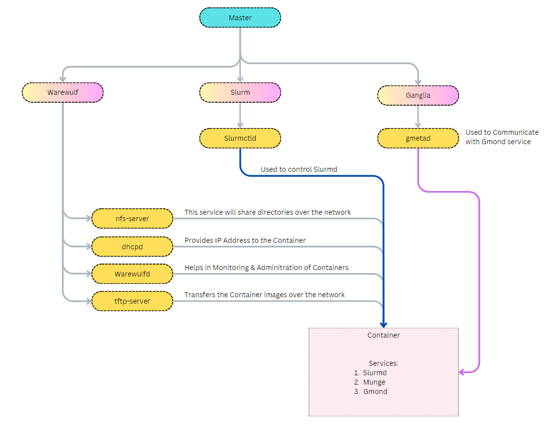

System Requirements

* RAM: 16 Gb
* HDD: 100 Gb
* Processors: 4 cores
* Network adapters
  + NAT
  + Host Only

Software Requirements

* Rocky Linux (8.8)
* Warewulf
* SLURM
* Ganglia

Setting up the master

* create a Virtual machine for master node

Step 1: Create new virtual machine in VMware Workstation

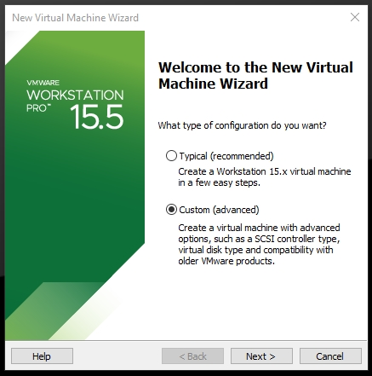

Step 2: Click next & choose `I will install Operating System Later`

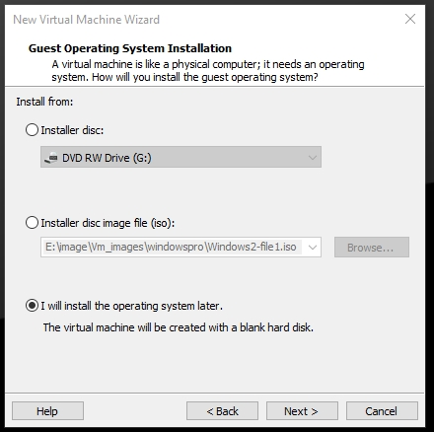

Step 3: Select Guest Operating System Type

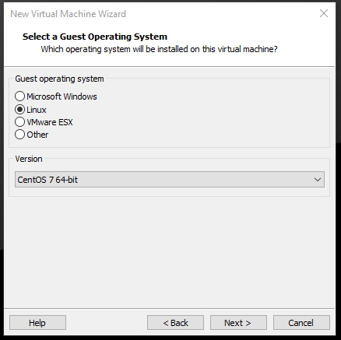

Step 4: Give name to your New VM

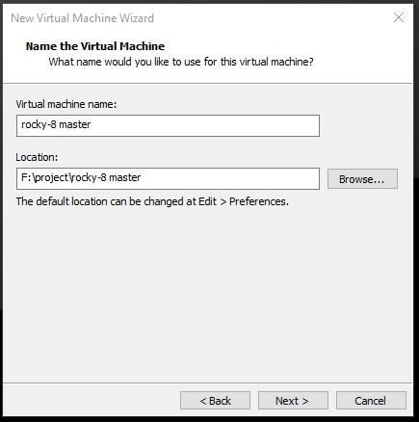

Step 5: Select no of processors for master

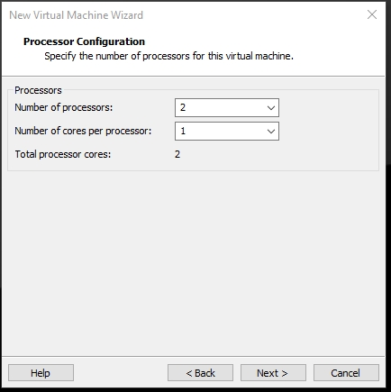

Step 6: next step is to define ram for new master machine

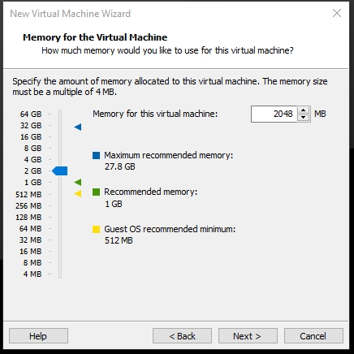

Step 7: Next step is to select Network Type

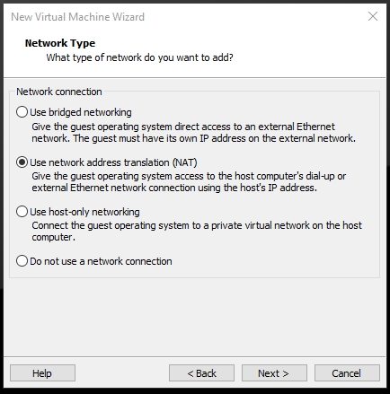

Step 8: Next step is to select disk & it’s size

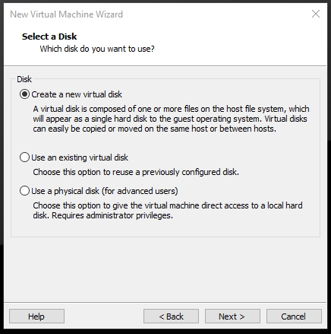

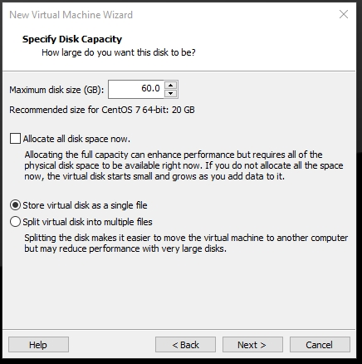

Step 9: Next Step is to add another network adapter & change its type to Host-only

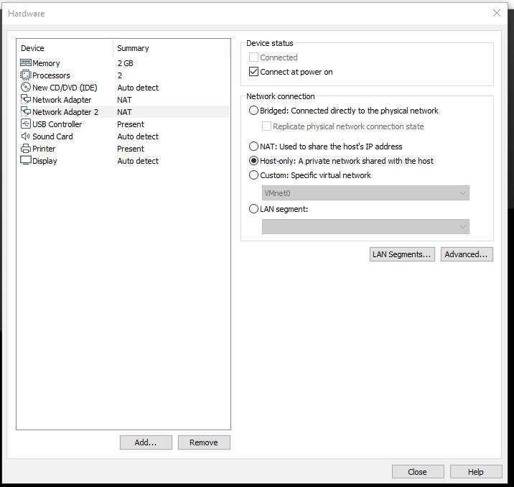

Step 10: Final step is to confirm the configuration and click finish

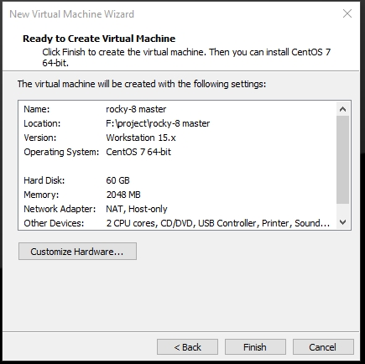

Installing OS on new VM

Step 1: select boot device and choose rocky Linux 8.8 iso & click open. Then start the virtual machine

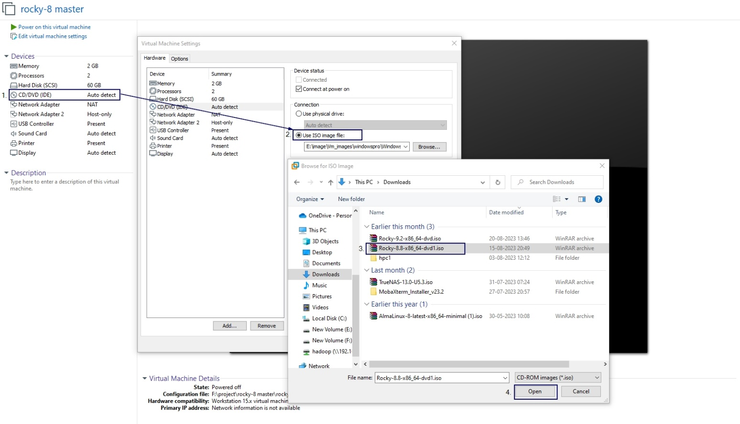

Step 2: After vm is started select the first option & press enter key

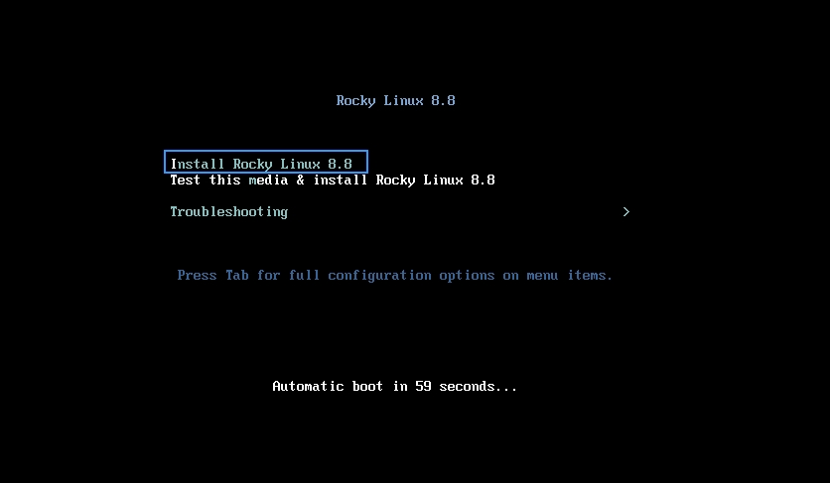

Step 3: Next step is to select language & press Continue button.

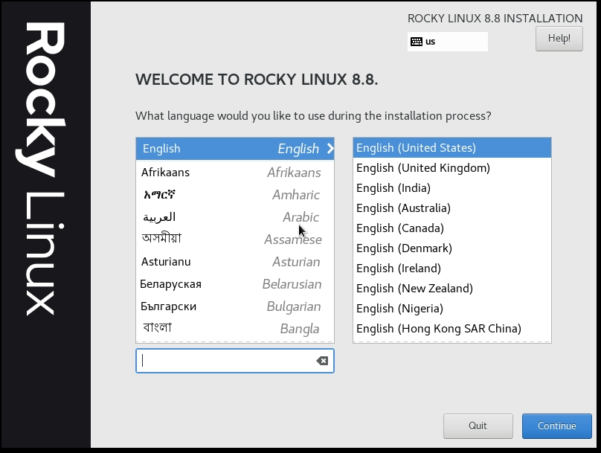

Step 4: setup the root password, Installation destination & click Begin Installation

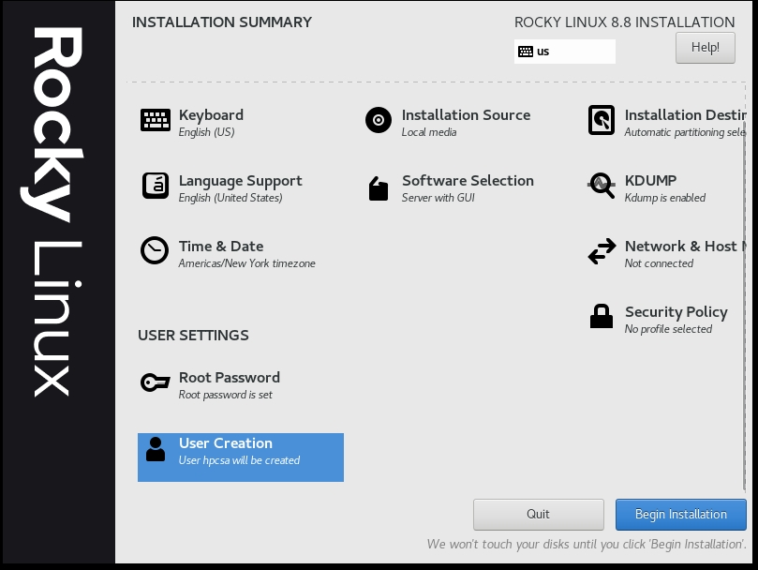

Step 5: After system has been installed click Reboot System

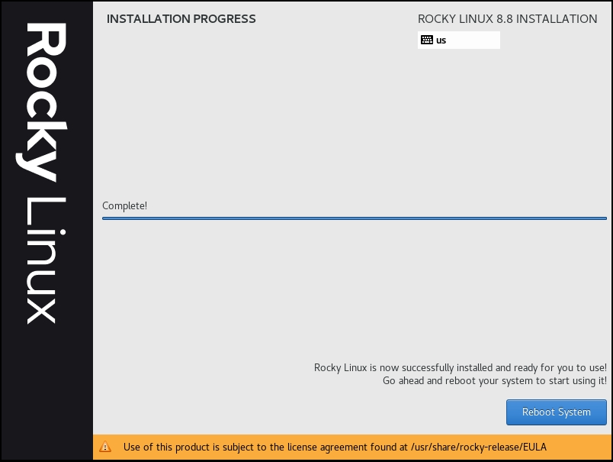

Step 6: Next step is to accept the EULA agreement

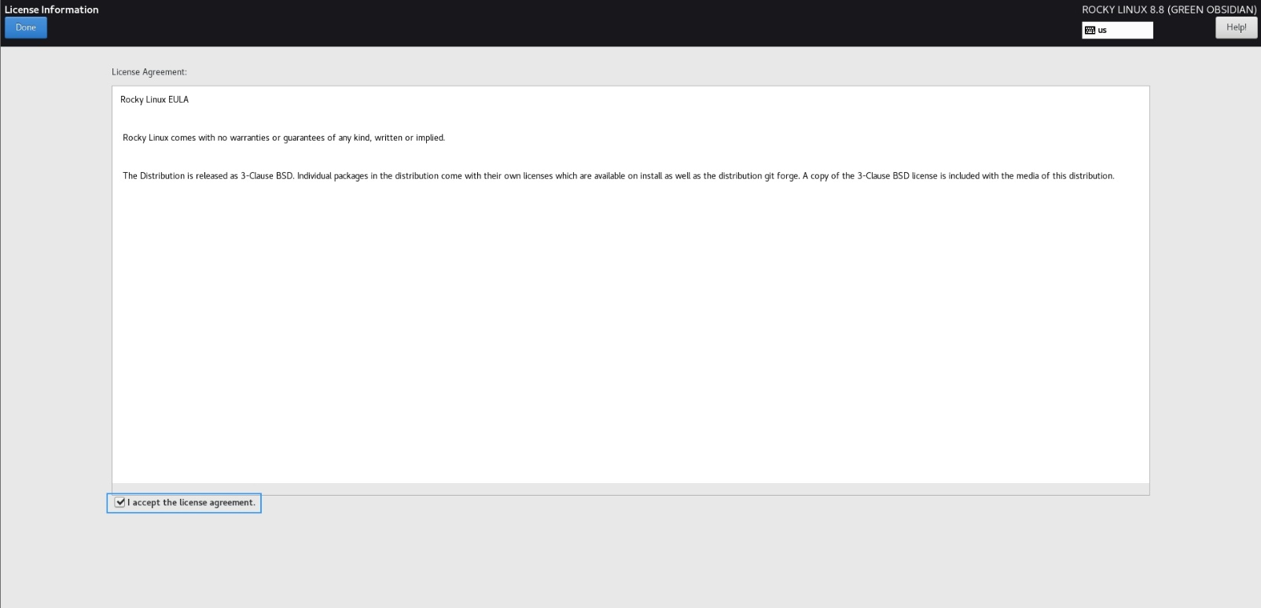

Step 7: Next step is to accept the agreement & click finish Configuration

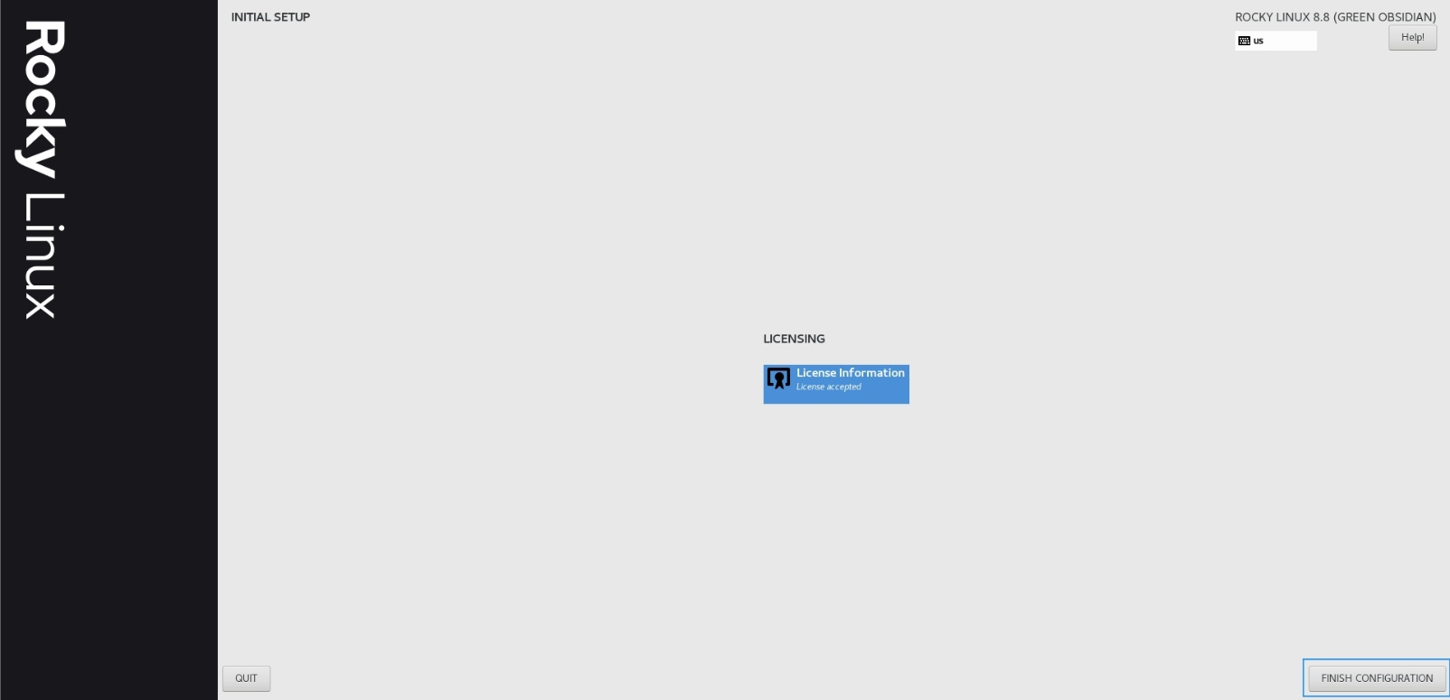

Step 8: in Next step, Enter the username & password on the login screen

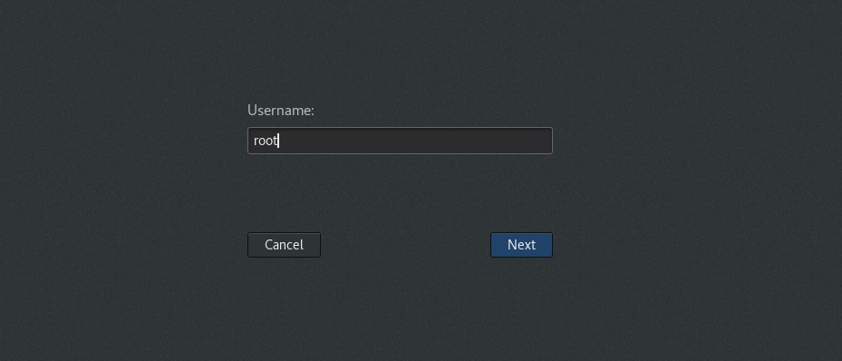

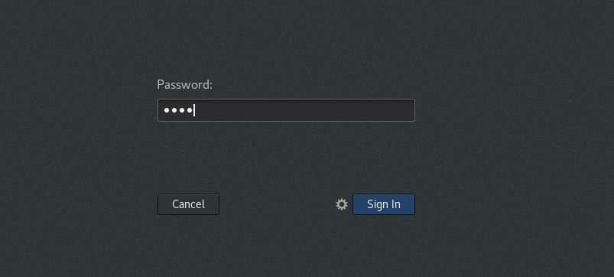

Step 9: Finally, we land the Rock Linux desktop Environment

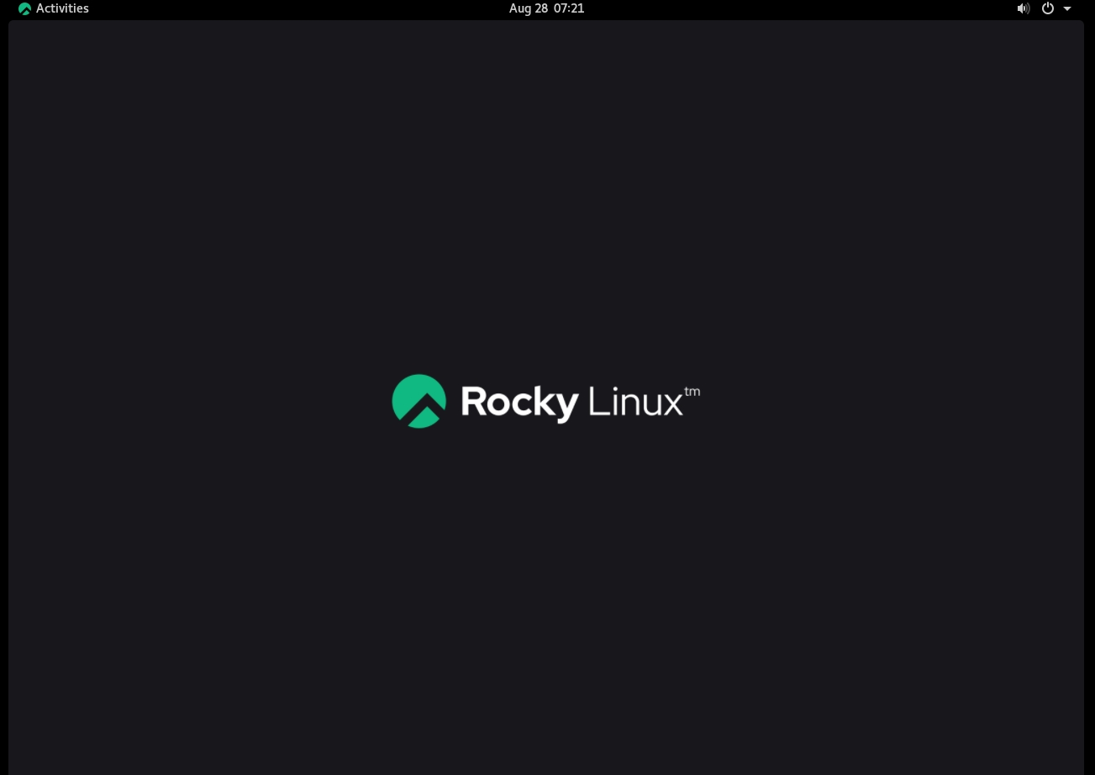

Warewulf Installation

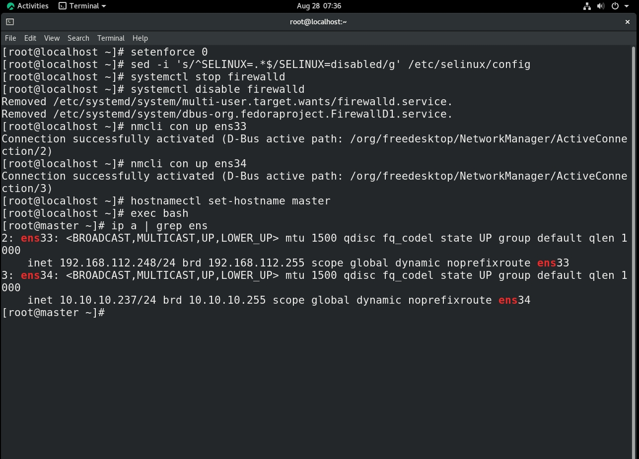Step 1: First, we need to disable the SELINUX, firewall and change hostname

Step 2: Next step is to add warewulf repository

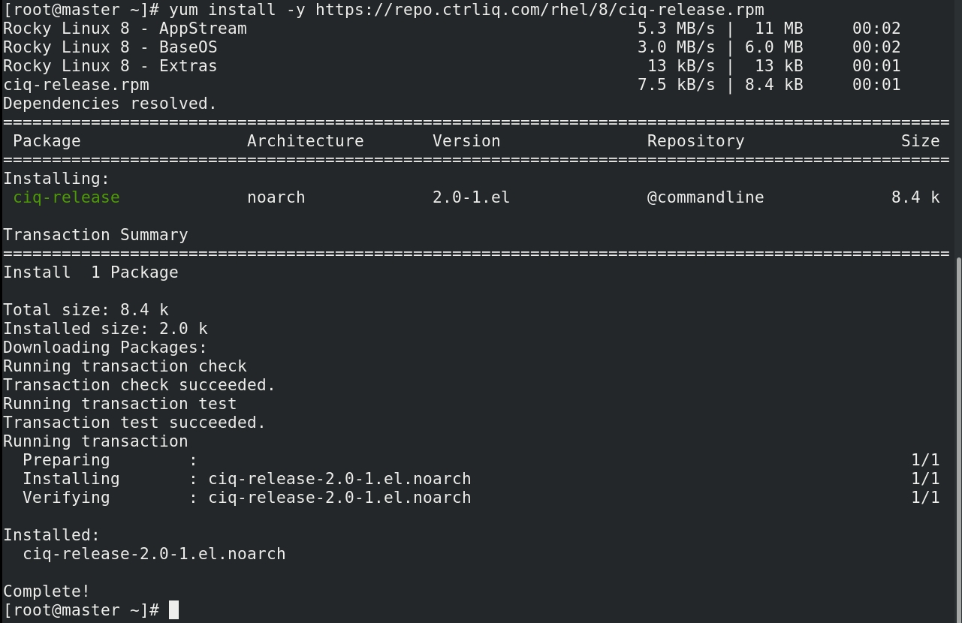

Step 3: Next step is to install warewulf

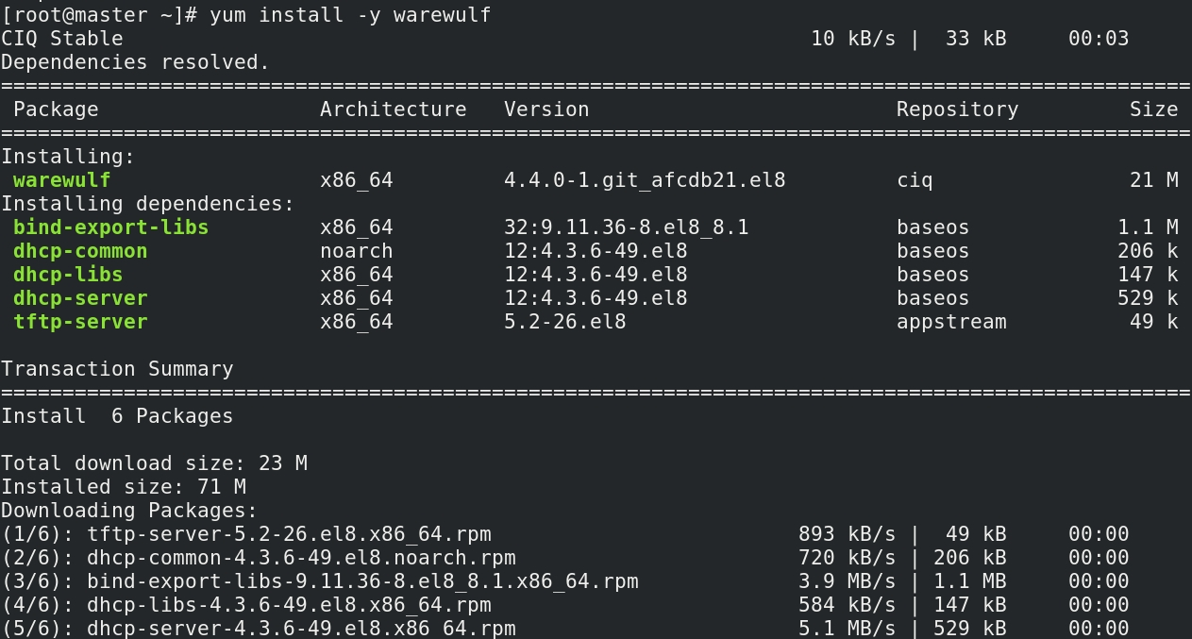

Step 4: Next step to edit config file

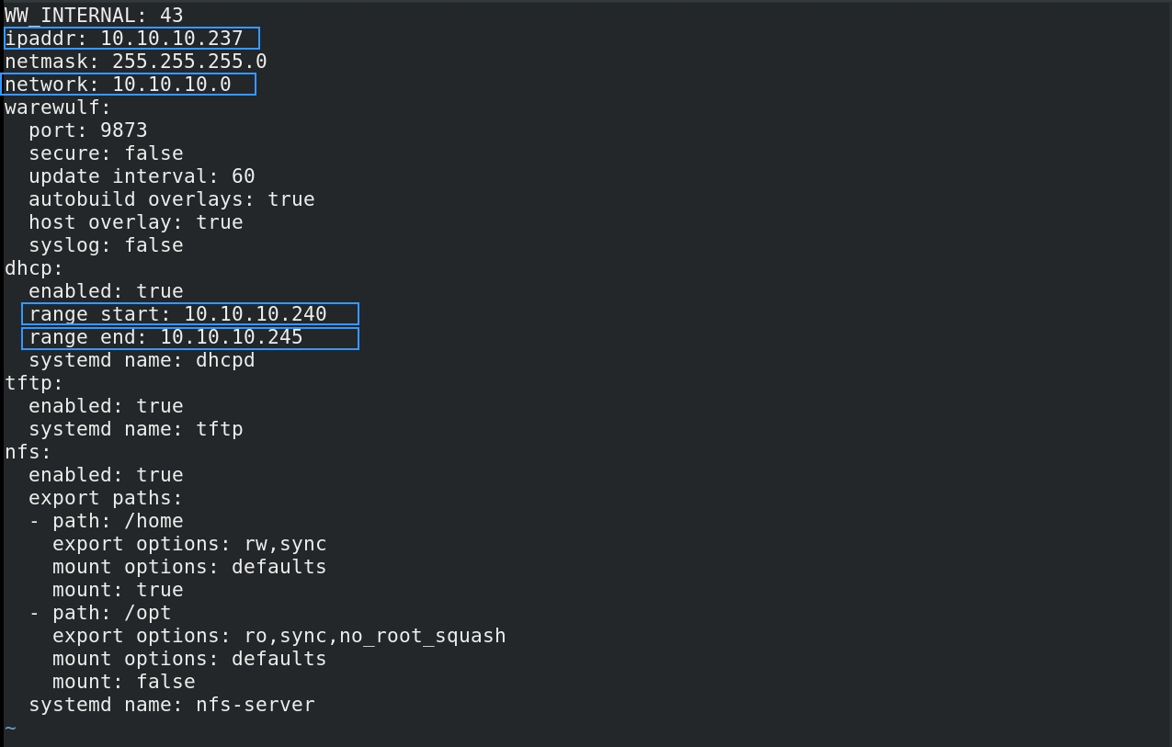

Step 5: Next step is to configure the warewulf

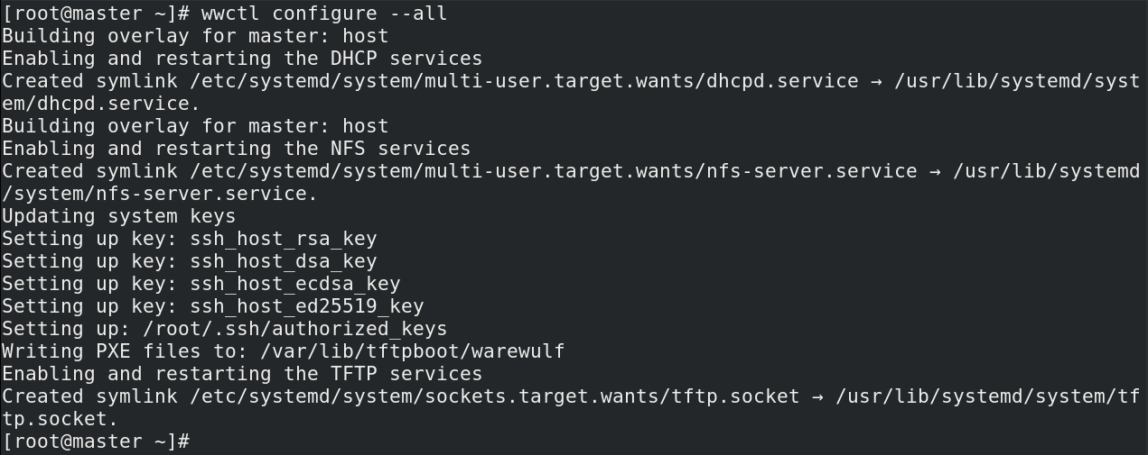

Step 6: Next we need to start the services required for provisioning

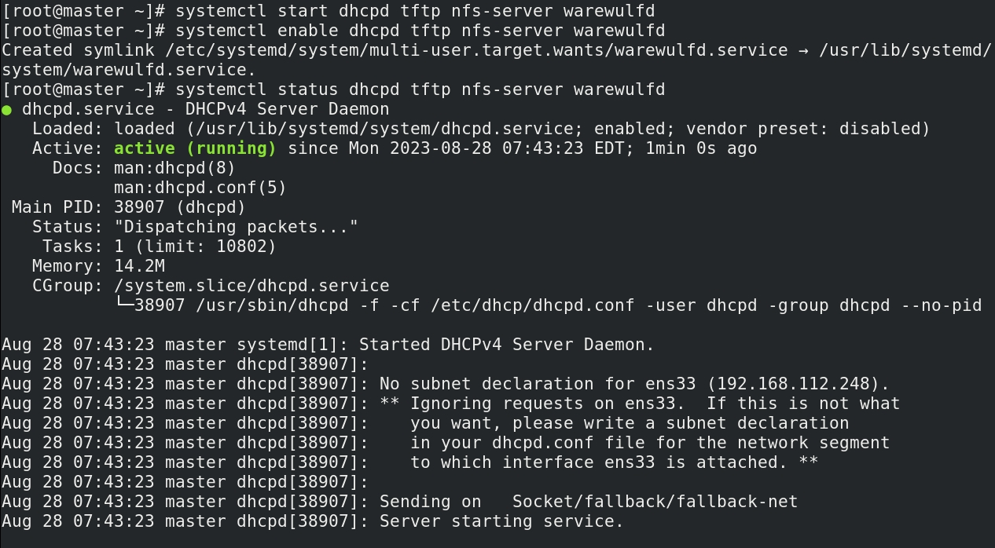

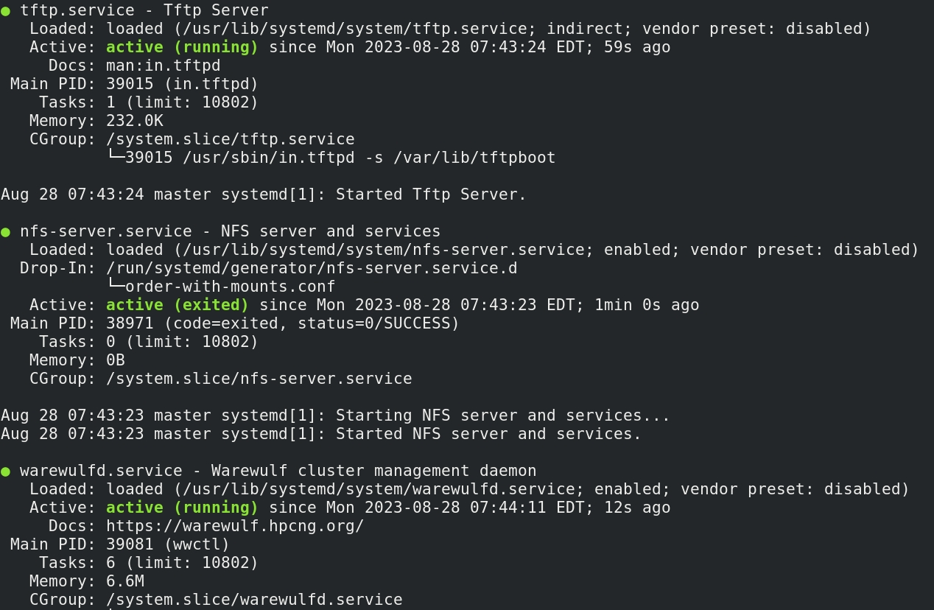

Step 7: Next step is to import container from docker hub & set password for it.

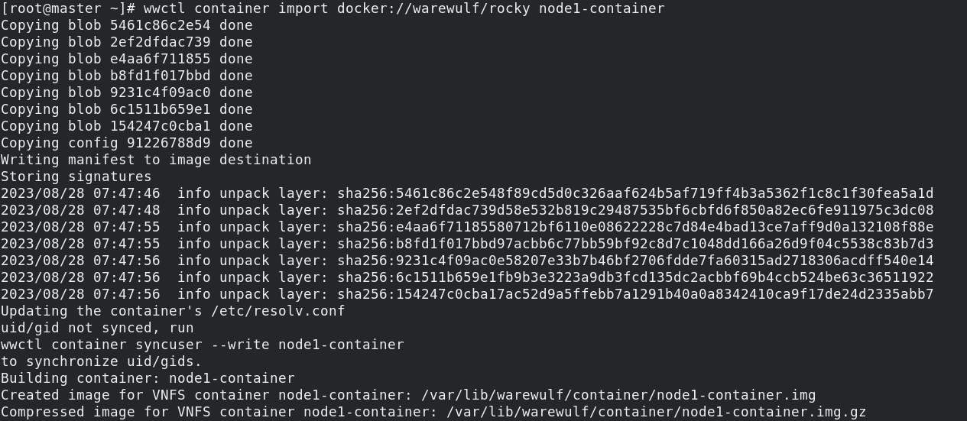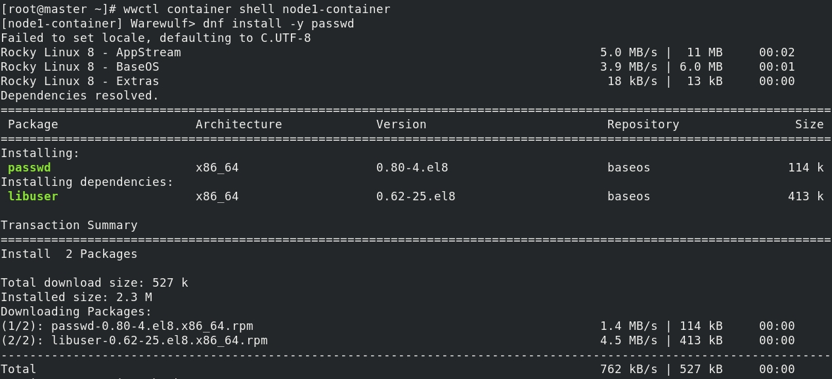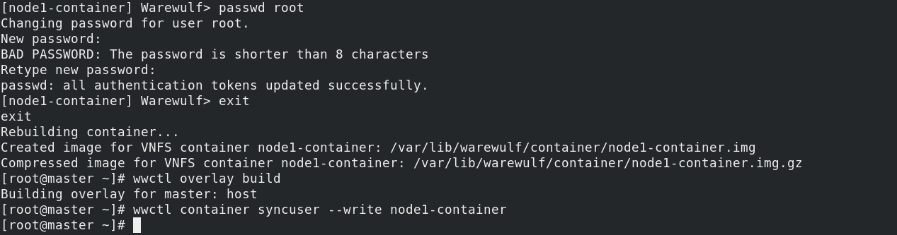

Step 8: Next step is to create a new node and test if it is booting or not.

Warning : RAM given to Node VM must be greater than the Container Size

1. click on create new VM
2. select “I will install the OS later”
3. Then choose OS type Linux
4. Choose No of processors
5. Give the RAM size for the Node
6. Then choose the Network mode(Host Only)
7. Then give the disk size. (I’ve given 0.001 Gb, in order to demonstrate that this process is stateless, doesn’t require HDD)

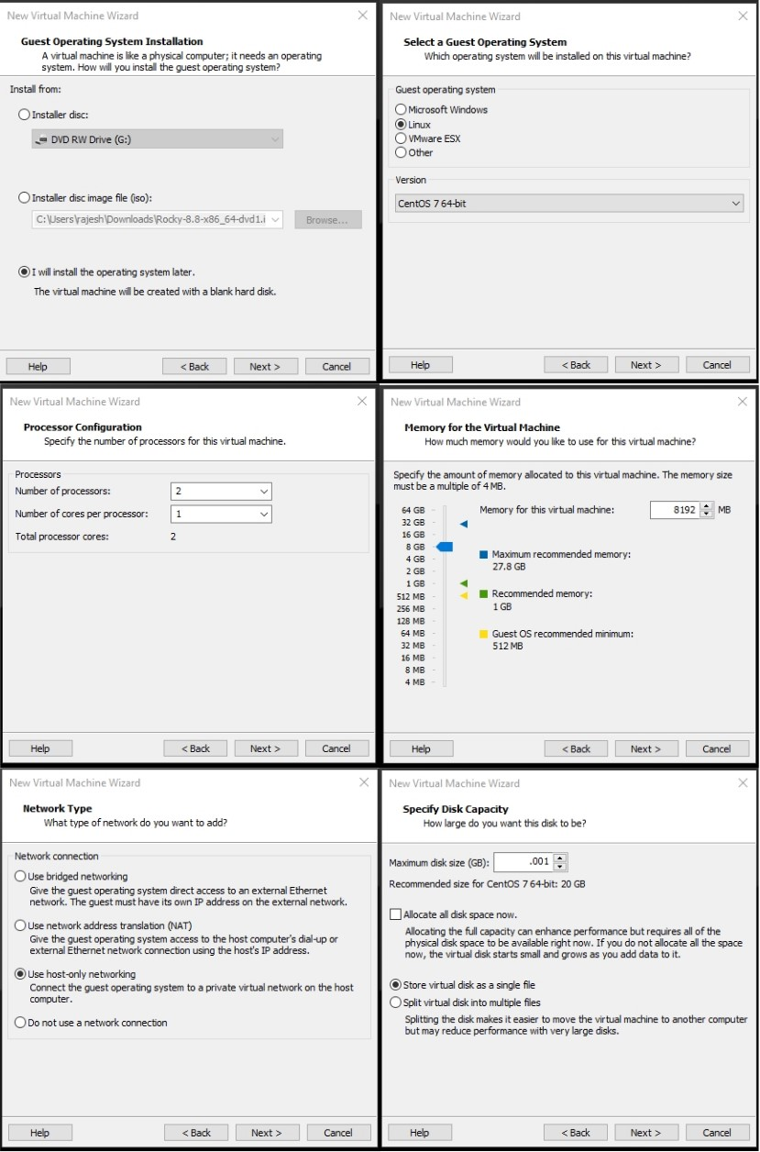



Step 9: add this node to warewulf



Step 10: Start the node

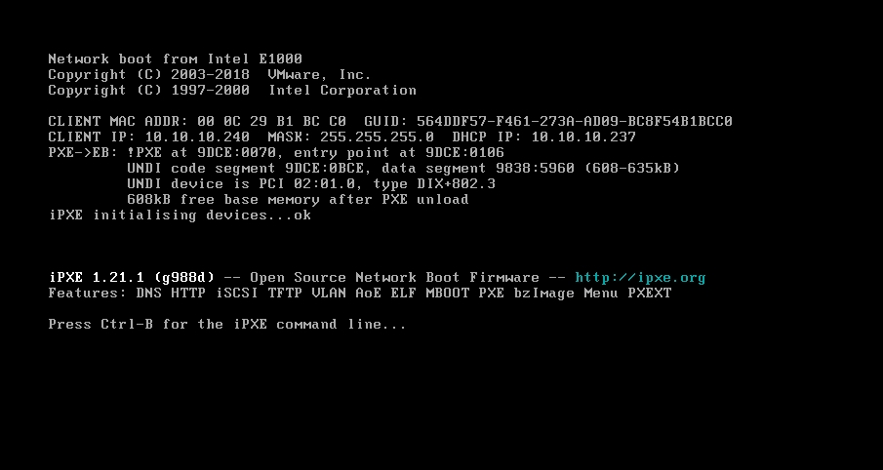

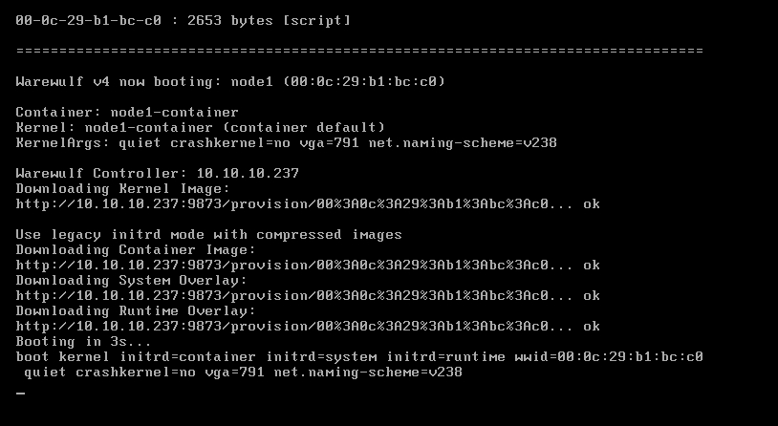

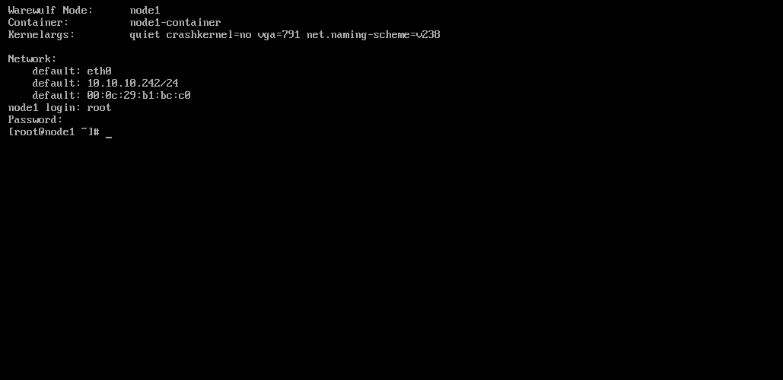

Installation of MUNGE

Step 1: Installing epel-release package

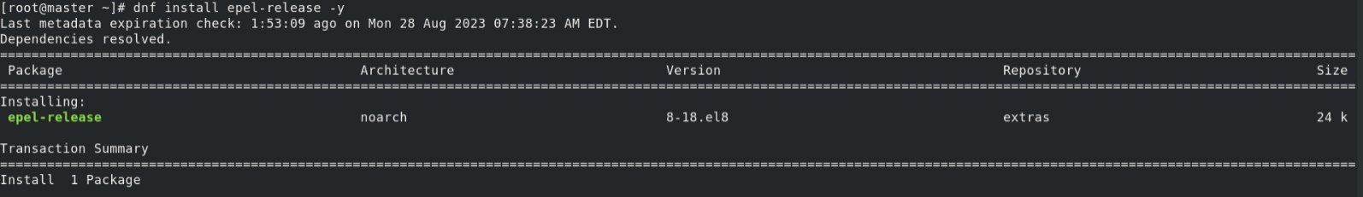

Step 2: enabling powertools & installing Munge packages

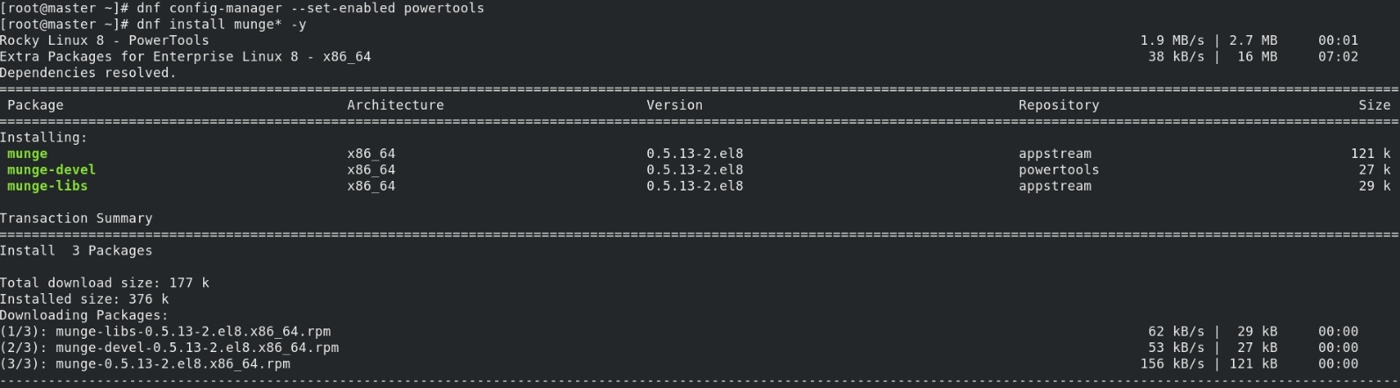

Step 3: installing random number generator tools, this will help in generating the munge key

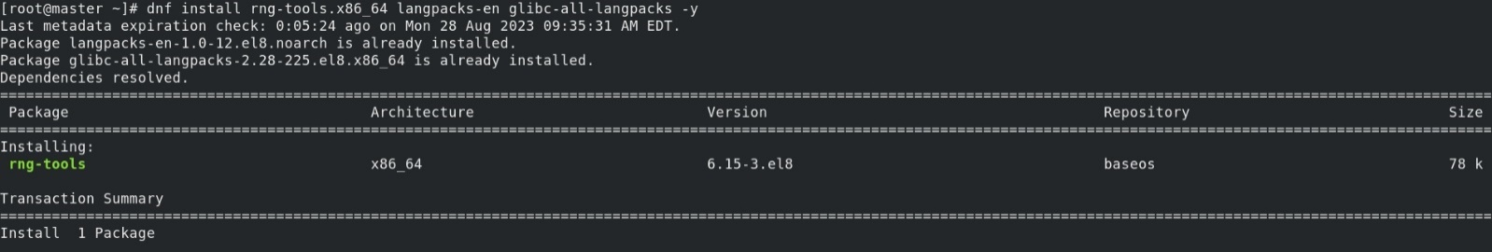

Step 4: Starting the rngd service

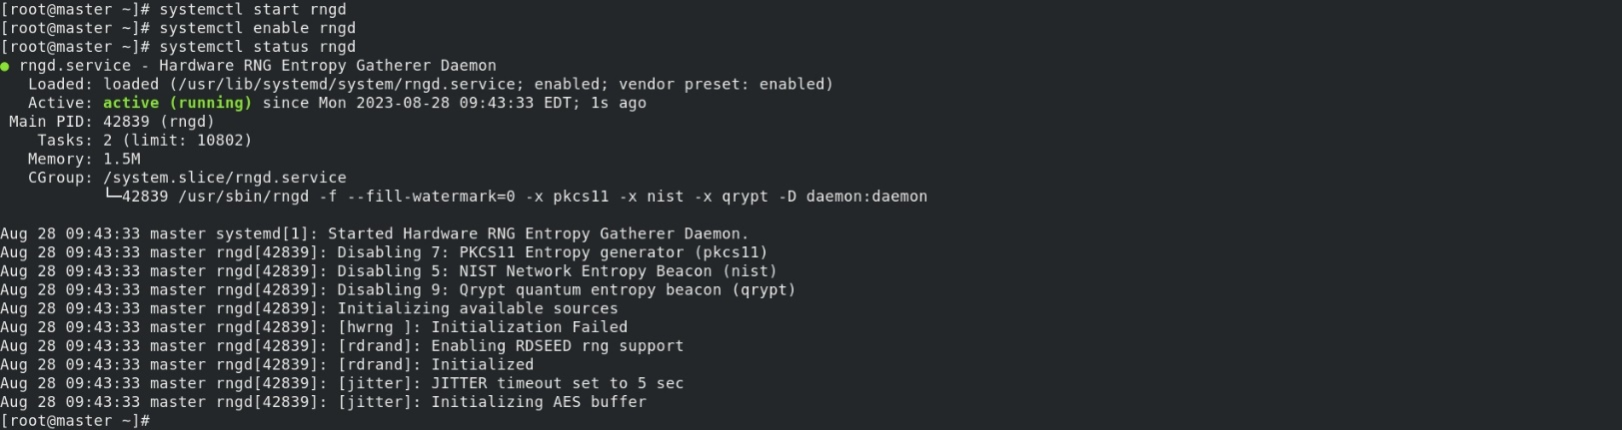

Step 5: create the munge key



Step 6: copying this munge key to container

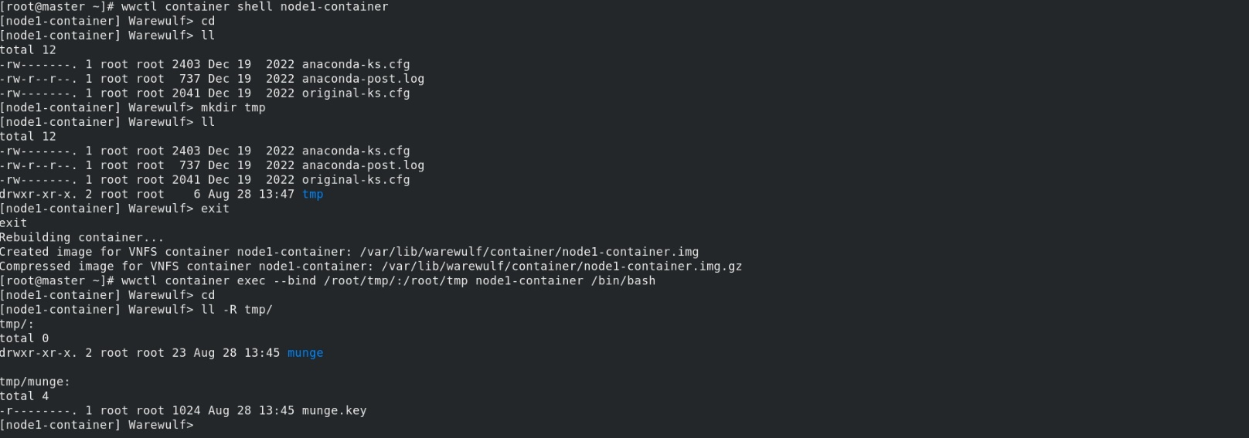

Step 7: installing the munge on the container

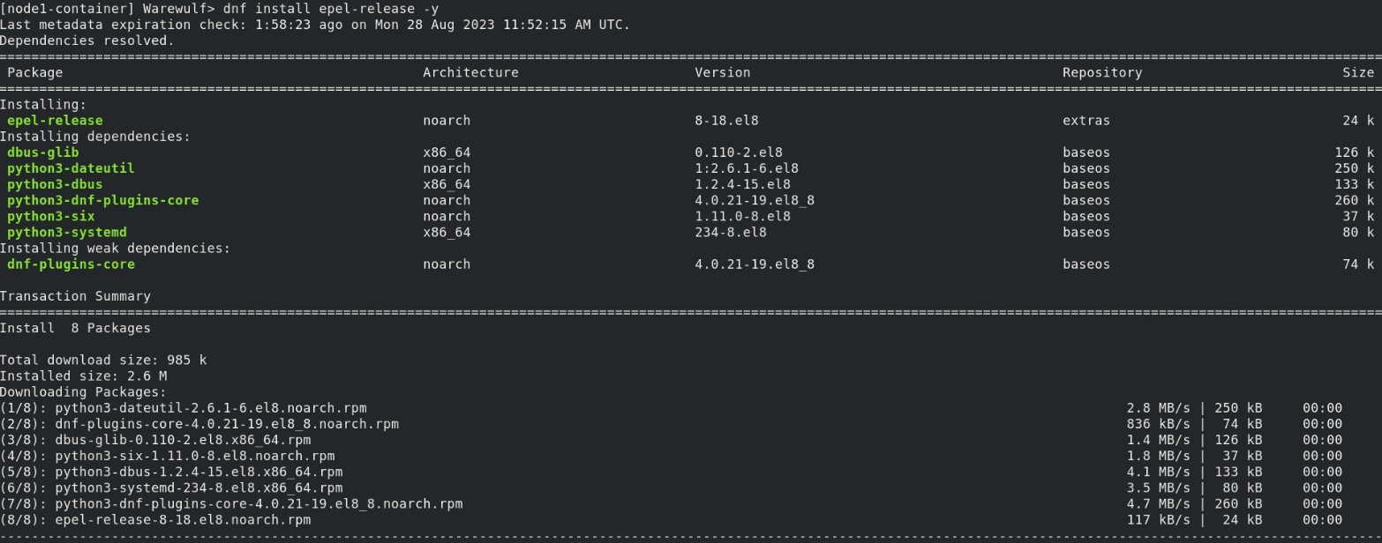

Step 8: copying the munge key from shared folder to munge path & changing it’s ownership. Finally, we have to rebuild the container

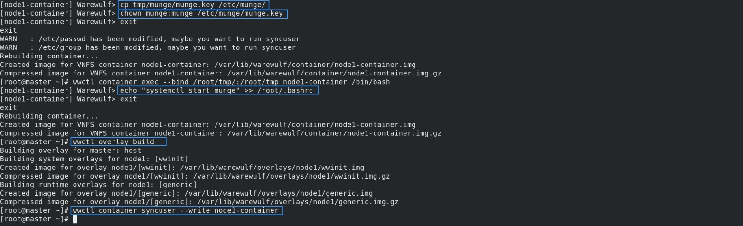

Step 9: checking status of munge service on Compute Node & Master

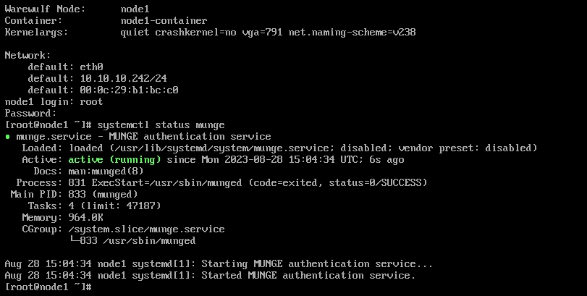

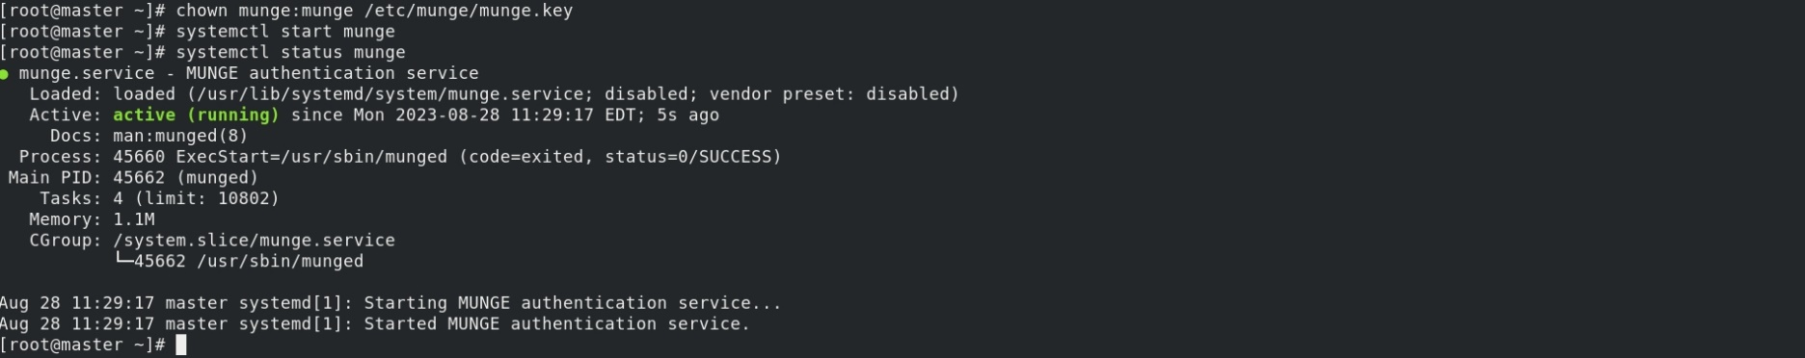

Installation of SLURM

Step 1: First, we have to download rpm-build & make packages

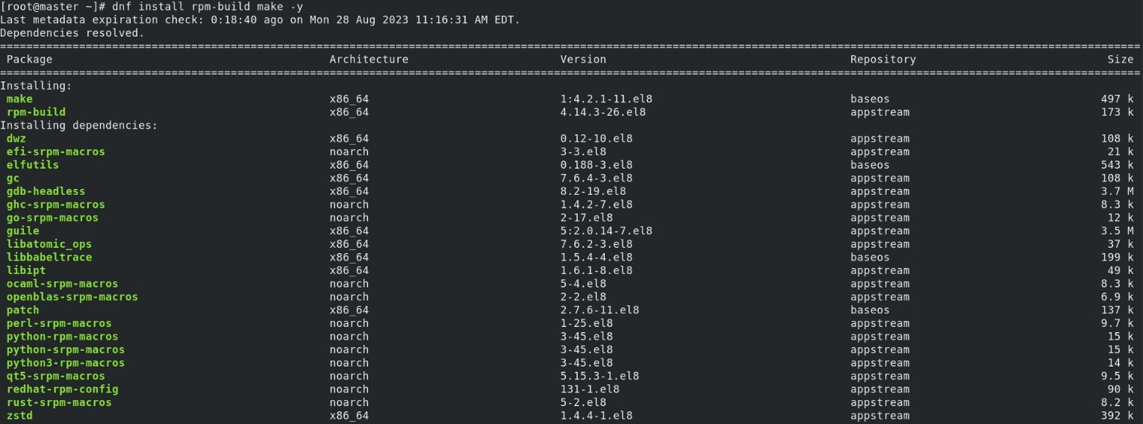

Step 2 : Next step is to download Slurmd packages

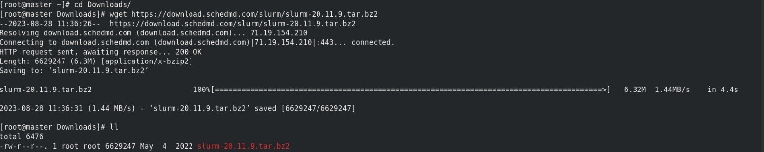

Step 3 : Next step is to download dependencies for Slurmd packages

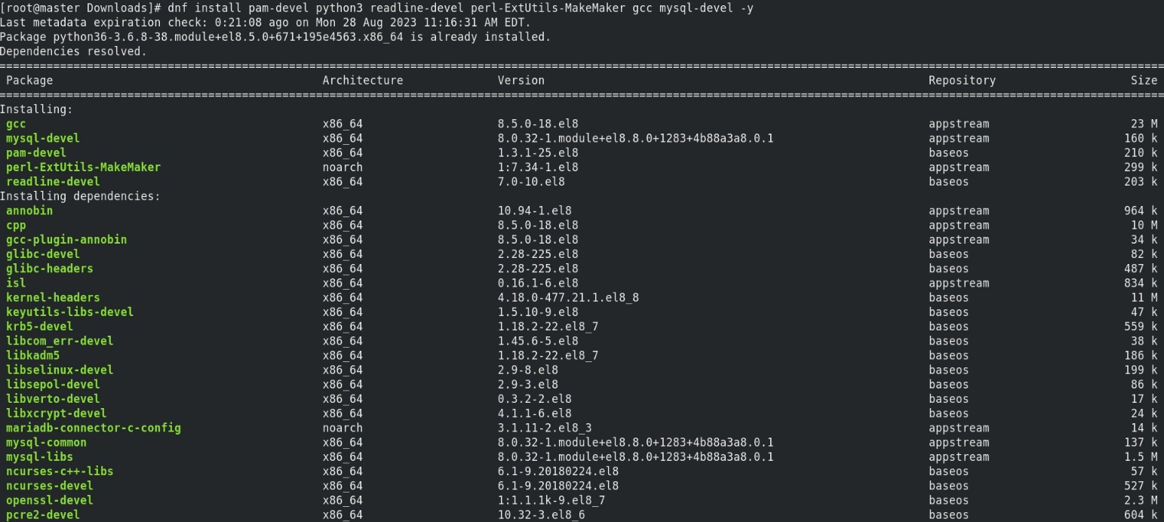

Step 4 : Next step is to build rpm from tar file

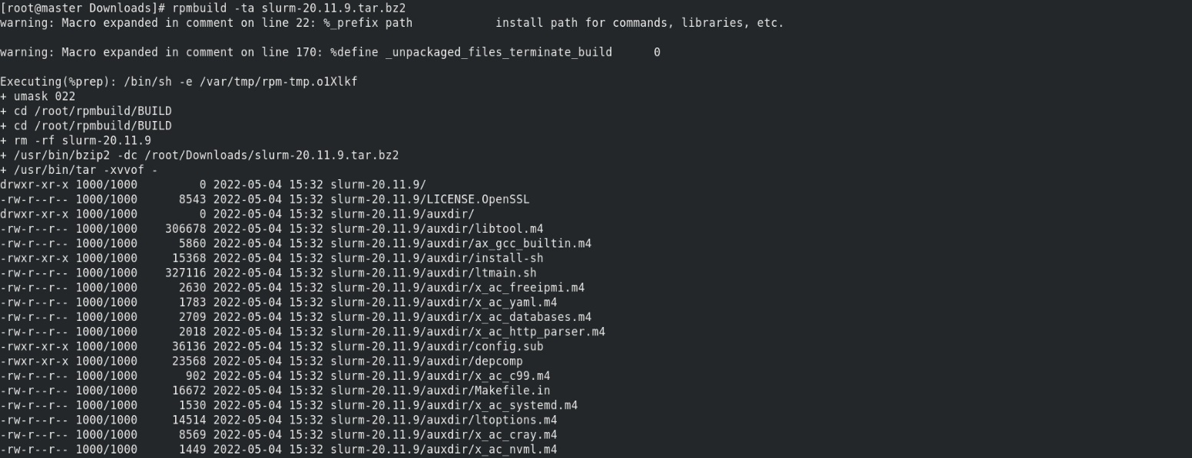

Step 5 : Next step is to create Slurm User to operate Slurm services

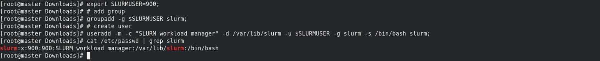

Step 6 : Next step is to check rpmbuild packages after rpmbuild packages has

been build

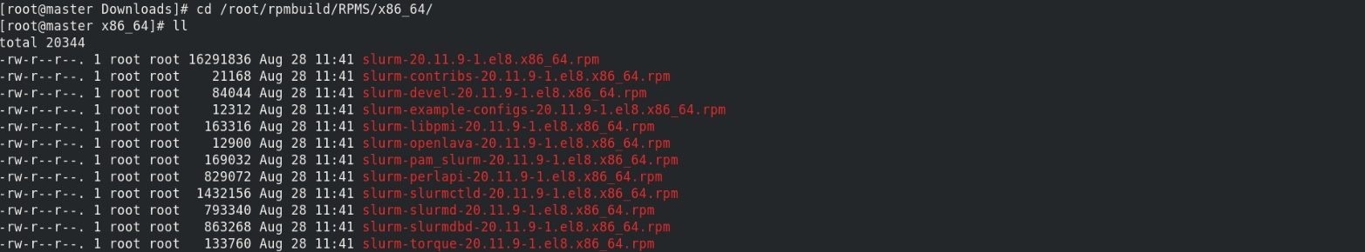

Step 7 : Next step is to install rpmbuild packages

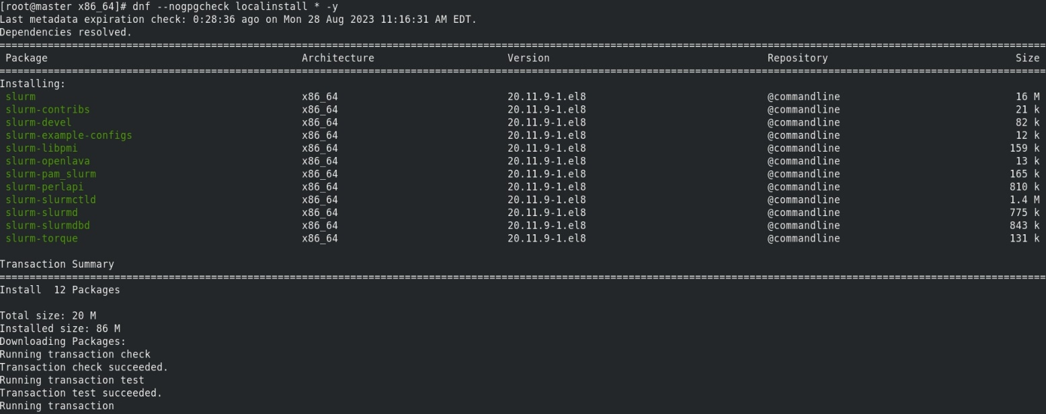

Step 8 : Next step is to copy Slurm packages from Master to Container

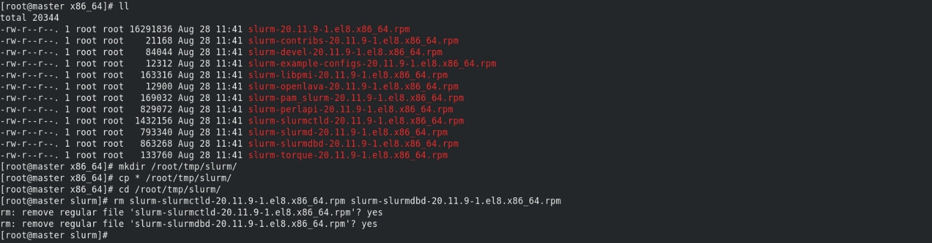

Step 9 : Next step is to make directory , change ownership and give permission

to Slurm User



Step 10 : Next step is to install Slurm on container

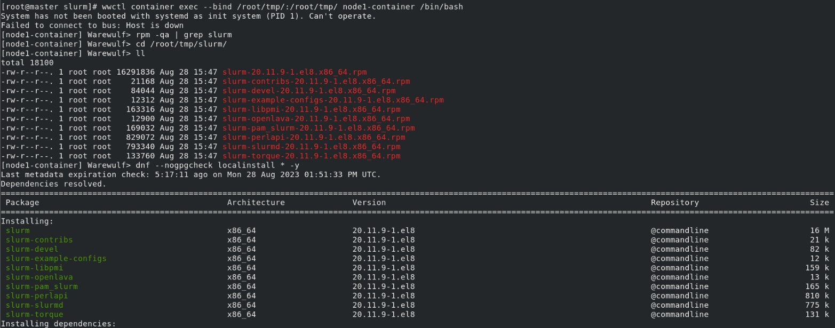

Step 11 : Next step is to edit the config file

Line no 11 : give name to this slurm cluster

Line no 12 : give hostname of slurmctld machine

Line no 92 : comment this line

Line no 93 : add node1 information, which can be obtained using “slurmd -C”

Save & quit config file



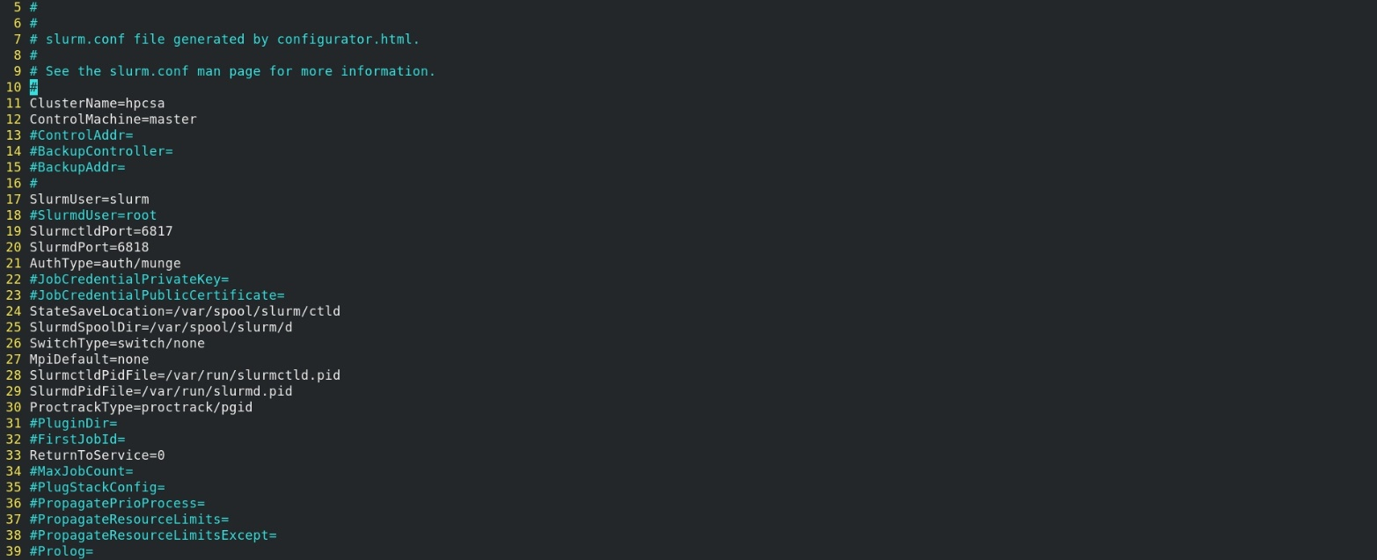





Note: to get this slurm configuration from node, node has to be in a booted state.

Otherwise, this command will show master machine configuration.

Step 12: Next step is to change ownership to slurm and restart the service

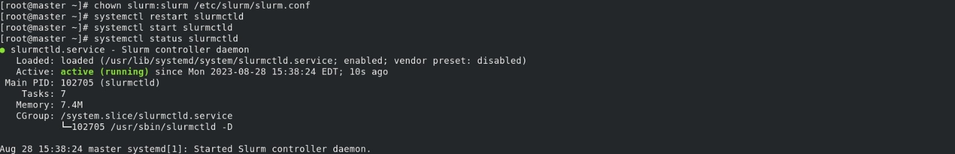

Step 13 : Next step is to create spool & log directories for Slurmd on Container

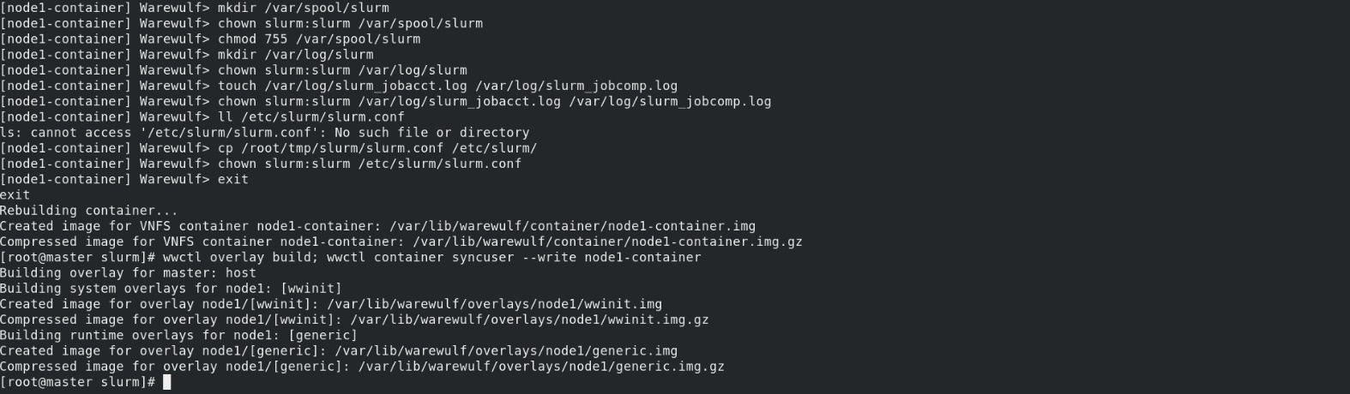

Step 14 : Next step is to reconfigure the warewulf

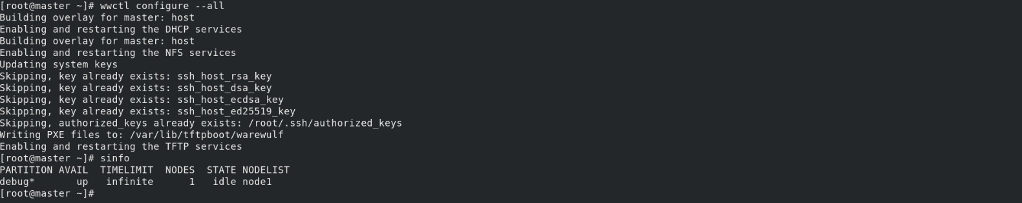

Step 15 : Next step is to reboot the Container & check all services

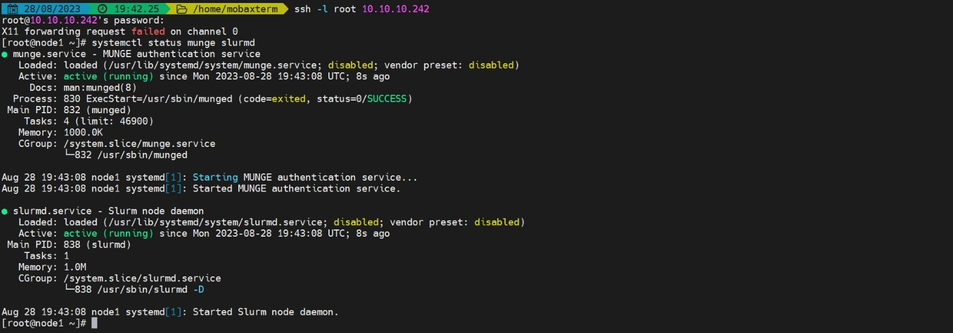

Step 16 : Next step is to confirm node has been added or not



Note : Node is visible to Slurm controller

Installation of Ganglia

Step 1 : First , we have to download Ganglia packages

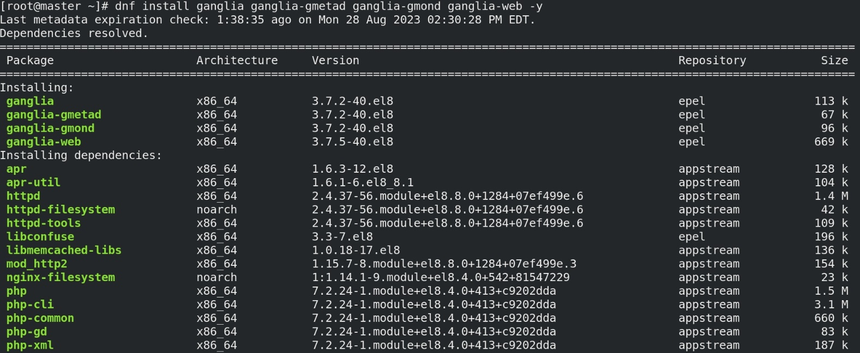

Step 2 : Next step is to edit the gmetad file

Line 44 : Change the Cluster name



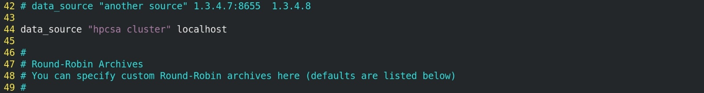

Step 4 : Next step is to edit gmond file

Line no 30 : give the cluster name

Line no 31 : give the hostname of the master machine

Line no 50 : give the ip address of the master

Line no 57 : comment this line

Line no 59 : comment this line



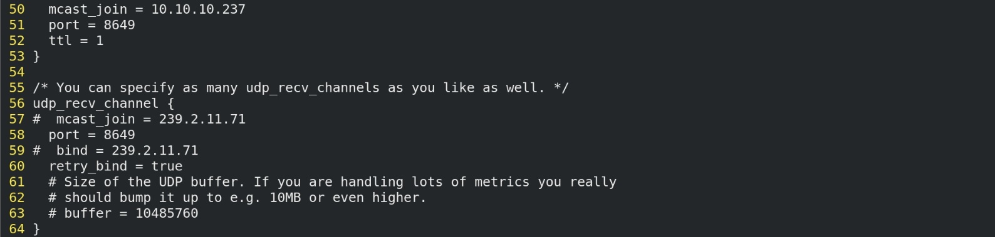

Step 7 : Next step is to start the services

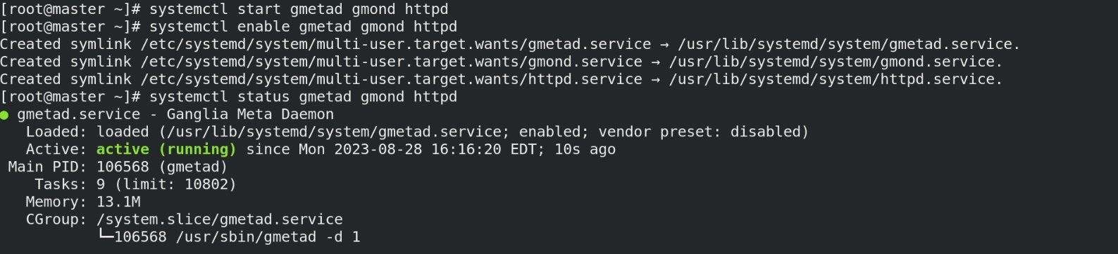

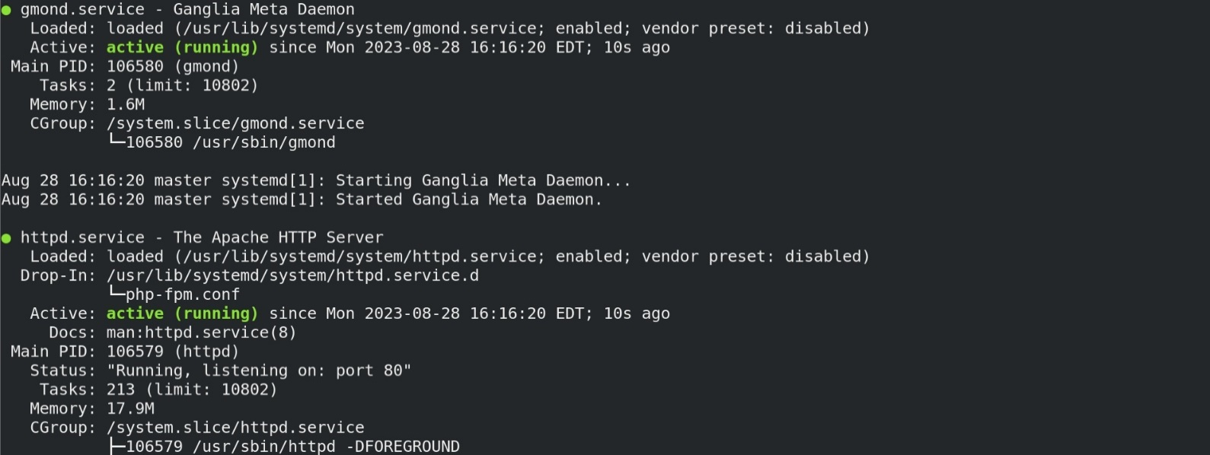

Step 8 : Next step is to install ganglia on container

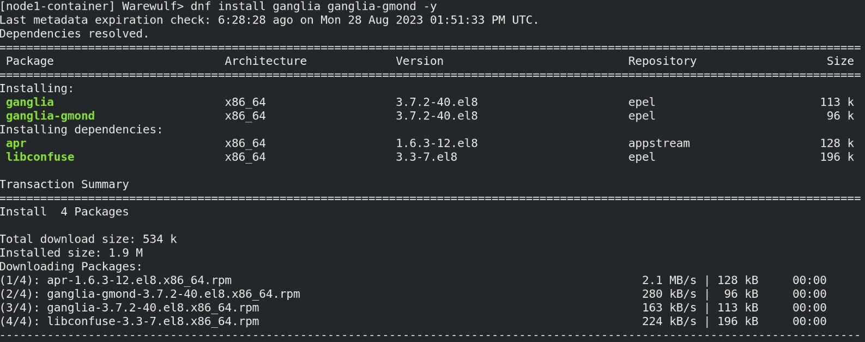

Step 9 : Next step is to edit gmond file on cluster

Line no 30 : give the cluster name

Line no 31 : give the hostname of the master machine

Line no 50 : give the ip address of the master

Line no 57 : comment this line

Line no 59 : comment this line

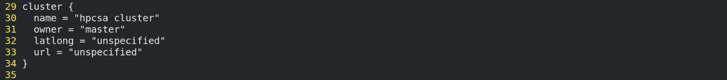

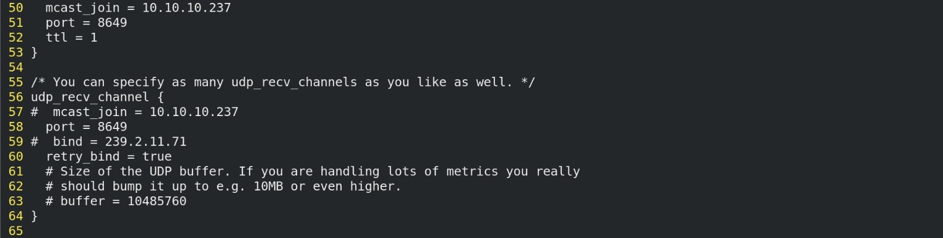

Step 10 : Next step is to add the gmond service in bashrc file

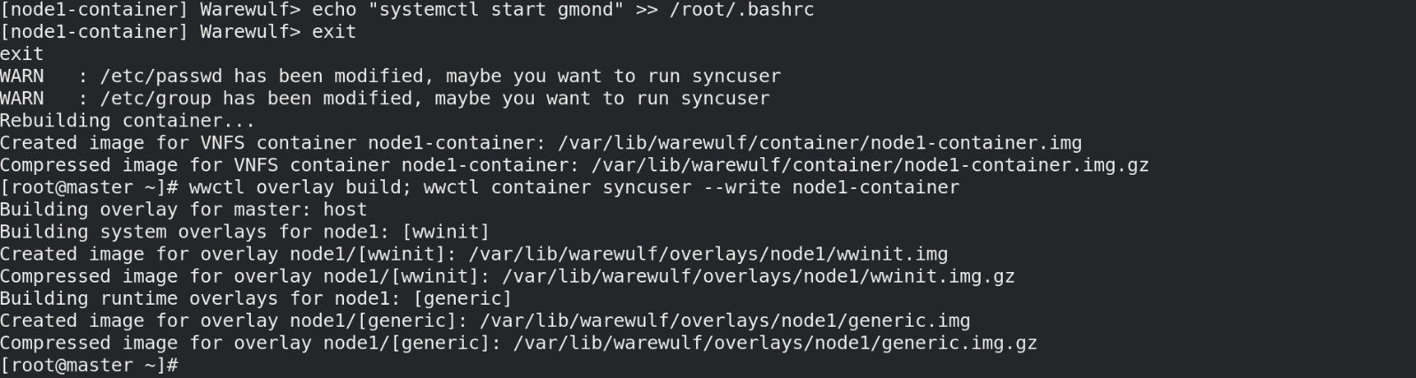

Step 11 : Next step is to reboot the node & check the status of the gmond service

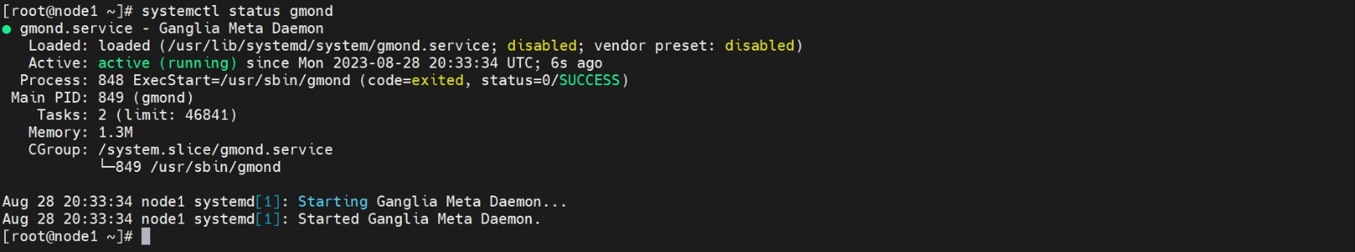

Step 12 : Next step is to open browser on master & check the ganglia cluster output

<https://localhost/ganglia>

Cluster Output:

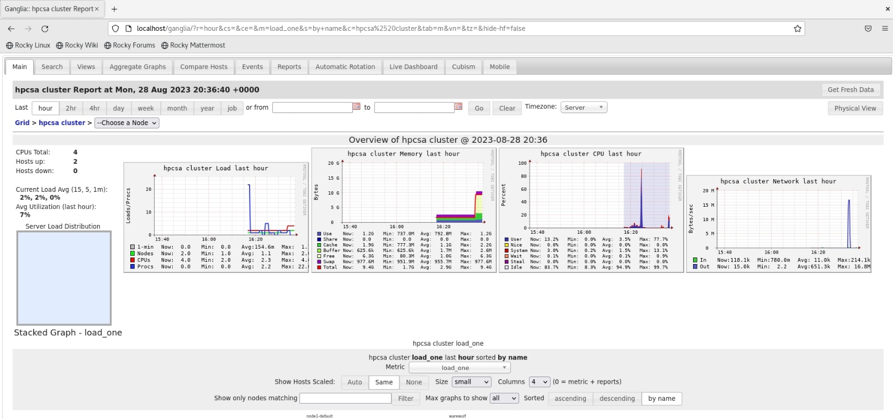

Node Result:

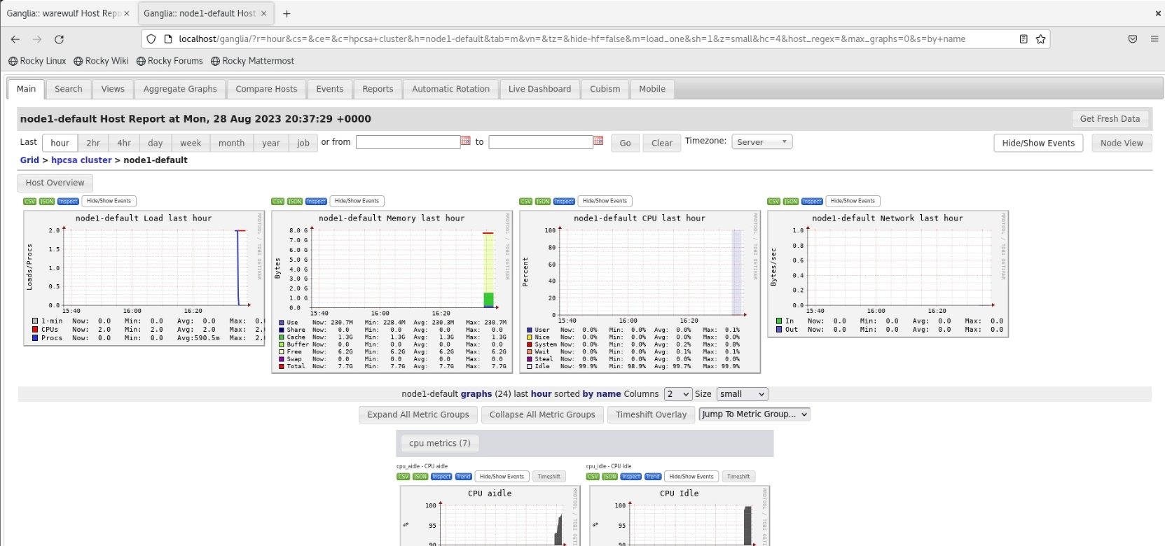

Master result:

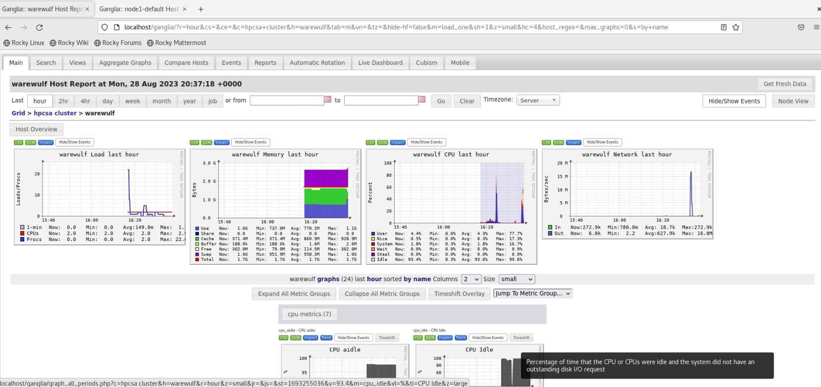

Troubleshooting

Error 1: hub_port_status failed (err = 110)

Solution: Remove Usb Controller from Vm settings

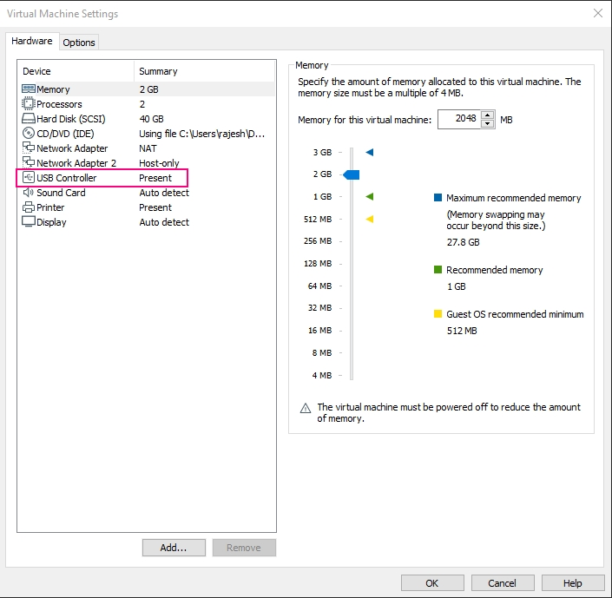

Error 2: Failed to set Locale, defaulting to C.UTF-8

Solution: install glibc-all-langpacks to resolve this issue

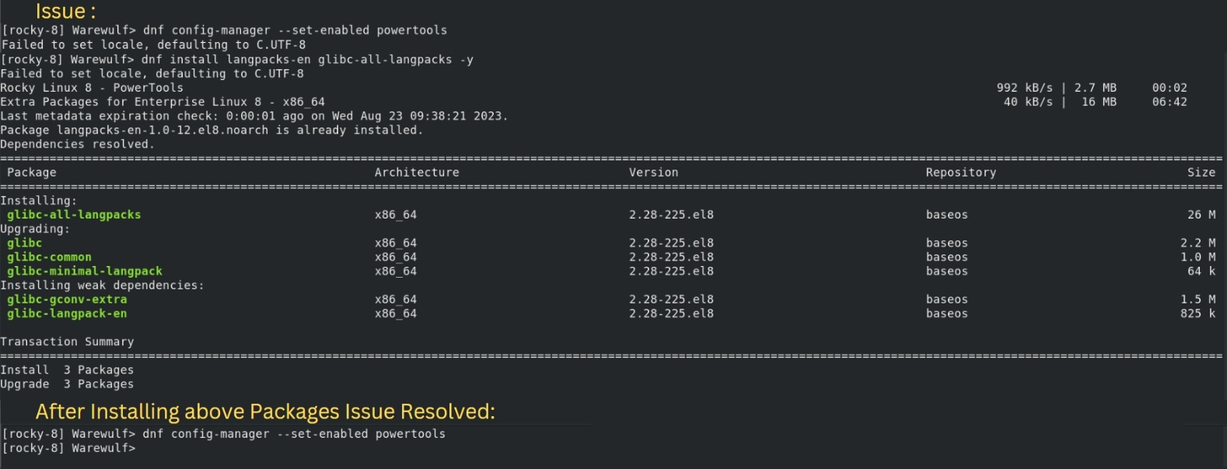

References & Bibliography

1. Warewulf Documentation

<https://warewulf.org/docs/development/>

1. Slurm Documentation

<https://slurm.schedmd.com/documentation.html>

Project Link

Github: https://github.com/shazz0512/HPC_CDAC_Project.git